**6.4.1.3 Packet Tracer – Configure Initial Router Settings**

Student Name: Lee Kai Yang

Student ID: 19WMR11671

Tutorial Group: RSF1S3G1

**Topology**

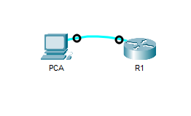

**Results Activity**

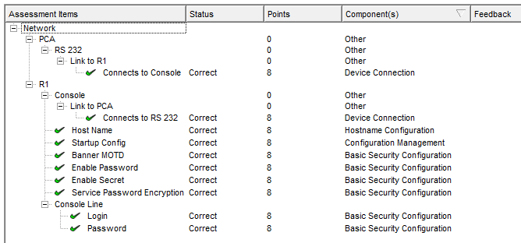

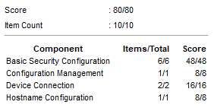

**Questions** 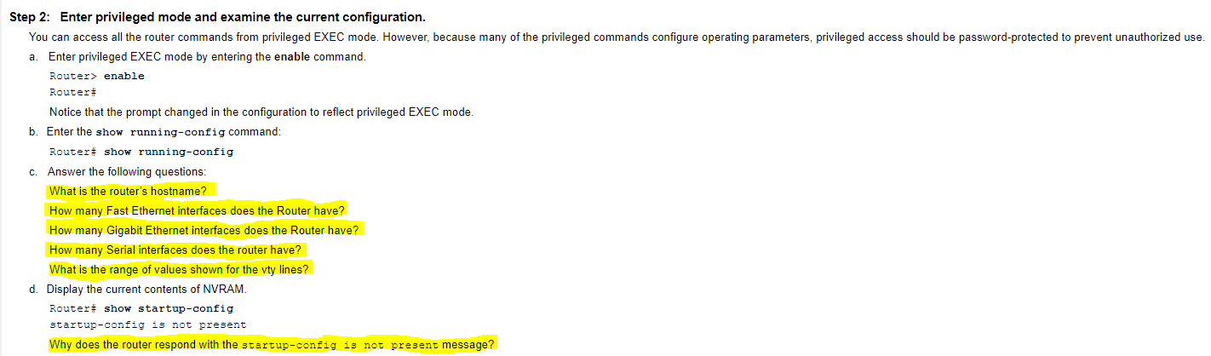

1. What is the router’s hostname?

Router

1. How many Fast Ethernet interfaces does the Router have?

4

1. How many Gigabit Ethernet interfaces does the Router have?

2

1. How many Serial interfaces does the router have?

2

1. What is the range of values shown for the vty lines?

0 - 4

1. Why does the router respond with the startup-config is not present message?

This message indicates that the configuration is not saved to NVRAM yet, it is still in the RAM.

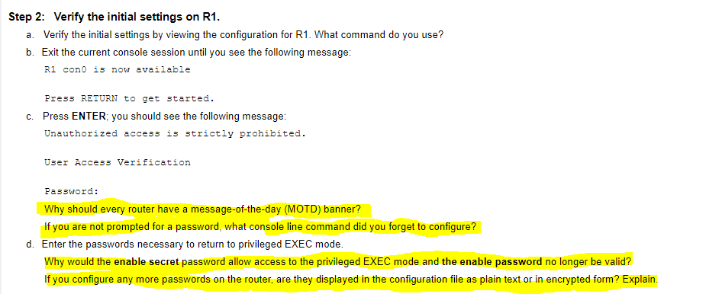

1. Why should every router have a message-of-the-day (MOTD) banner?

This is because message-of-the-day (MOTD) banner can warn unauthorized users that their access is prohibited, and the unauthorized users will know that they have to contact the network admin to request access.

1. If you are not prompted for a password, what console line command did you forget to configure?

login

1. Why would the **enable secret** password allow access to the privileged EXEC mode and **the enable password** no longer be valid?

This is because both **enable secret** password and **enable** password are configured. Therefore, the **enable secret** password overrides the **enable** password.

1. If you configure any more passwords on the router, are they displayed in the configuration file as plain text or in encrypted form? Explain.

They will be displayed in encrypted form. This is because the command service password-encryption encrypts all current and future passwords.

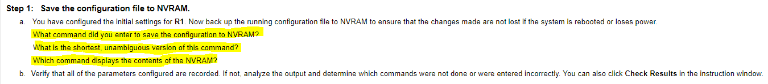

1. What command did you enter to save the configuration to NVRAM?

copy running-config startup-config

1. What is the shortest, unambiguous version of this command?

copy r s

1. Which command displays the contents of the NVRAM?

show startup-config

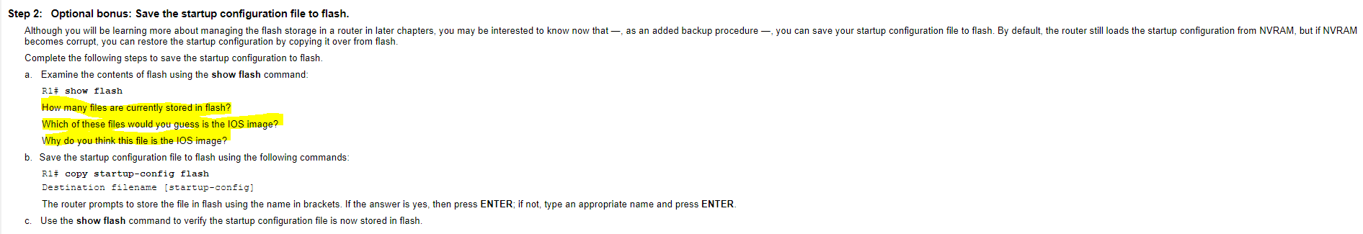

1. How many files are currently stored in flash?

3

1. Which of these files would you guess is the iOS image?

c1900-universalk9-mz.SPA.151-4.M4.bin

1. Why do you think this file is the iOS image?­

Because this file has a .bin file extension whereas the other two are .xml.